Saturday March 20th
Palm Bay Play Day
Bill Madden Park
2860 Eldron Blvd. SE
Palm Bay, FL 32909
Hosted By:
Palm Bay Plays- A UCF Cornerstone Group
With help from Kathy Maldonado, the daughter of Bill Madden

Geocaching brought to you by:
Space Coast Geocaching Association
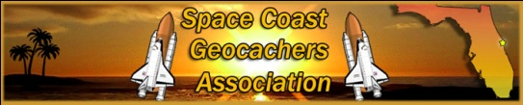
http://www.spacecoastgeocachers.com/
From 9 am till 11am

Karate Demonstration brought to you by:
Boom Boom Pow Parties
http://www.boomboompowparties.com/
Presentations: From Noon till 1 pm
Representatives: From 10 am till 2 pm

Dance Presentation brought to you by:
The Dance Factory of Brevard
http://www.dancefactoryofbrevard.com/
From 1:30 pm till 2 pm

Fun Activities for the kids:
Bounce House:
Space Walk of Melbourne
http://www.brevardparties.com/spacewalkofmelbourne.htm

Tom Loomis with
Clowns, Balloon Animals, and Face Painting
Fun Activities for kids of all ages
New Playground Facility
FOOD AND DRINKS!!!!
Food Donated By: Sonic Drive In
Read more about us @ www.palmbayplays.yolasite.com

